1. Data Ingestion & Standardization Module
Code Location:
load_jsonl
function and Steps 1–3 in
main()
.
What it does:
Loads Data: Reads the raw Software.jsonl (reviews) and meta_Software.jsonl (product info) line-by-line to avoid memory issues.
Standardizes: Renames varying column names (e.g., changing reviewerID → user_id, unixReviewTime → timestamp) so the rest of the system has a consistent format.
Fixes Types: Ensures numerical columns like rating and price are actual numbers/floats and not strings.
2. Text Processing Module
Code Location:
clean_text
function and Step 4 in
main()
.
What it does:
Cleaning: Removes noise from reviews like HTML tags, URLs, emojis, and special characters.
Normalization: Converts text to lowercase and expands contractions (e.g., "can't" → "cannot").
NLP: Uses NLTK to remove "stop words" (common, low-value words like "the", "and") and performs lemmatization (converting words like "running" → "run") to prepare the text for analysis.
3. Trust Scoring Module
Code Location:
TrustworthyRecommender
class and Step 5 in
main()
.
What it does:
User Trust: Calculates a score for users based on their verified purchase history and helpful votes.
Product Trust: Scores products based on average ratings, review count confidence, and price analysis (detecting price outliers).
Seller Trust: Aggregates the trust scores of all products belonging to a specific seller.
Final Score: Combines these three signals (weighted 55% Product / 35% User / 10% Seller) into a single final_trust_score.
4. RL Training Module (The "Brain")
Code Location:
TrustworthyRLEnvironment
class and Step 8 in
main()
.
What it does:
Environment: Defines the "world" for the AI, where the State is the product's trust profile and the Action is setting a "threshold" for recommendation.
Training: Uses the PPO (Proximal Policy Optimization) algorithm to train an agent. The agent learns to set dynamic thresholds that maximize "Trust Accuracy" (rewarding it for correctly identifying trustworthy items while penalizing risky recommendations).
5. Evaluation Module
Code Location: Step 9 in
main()
.
What it does:
Testing: Runs the trained AI model against a set of test products (separate from training).
Metrics: Calculates key performance indicators:
Trust Accuracy: How close the AI's decision was to the mathematical trust score.
Recommendation Rate: What percentage of products the AI approved.
Average Reward: The overall "score" the AI achieved during testing.
6. Prediction & Demo Module
Code Location: Step 10 in
main()
(specifically the
predict_product_trust
inner function).
What it does:
Live Decision: Takes a specific product ID (ASIN), feeds its data into the trained model, and outputs a binary recommendation: ✅ TRUSTWORTHY or ❌ RISKY.
Explanation: Prints a detailed reasoning block showing why the decision was made (e.g., "Trust score 0.85 > Threshold 0.70").

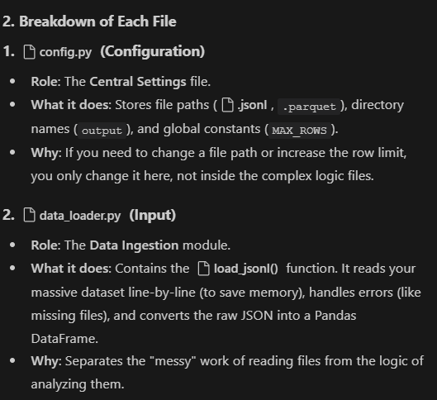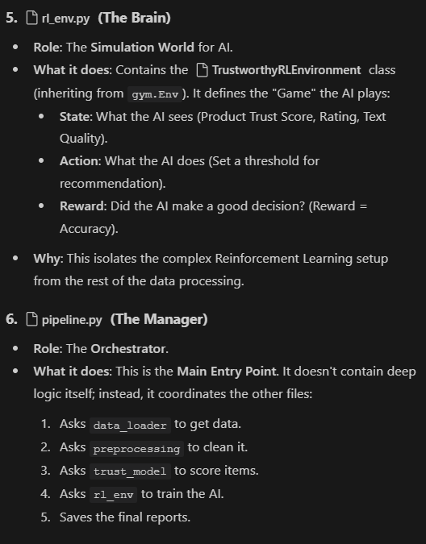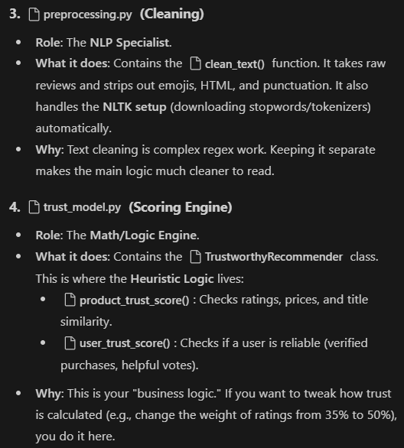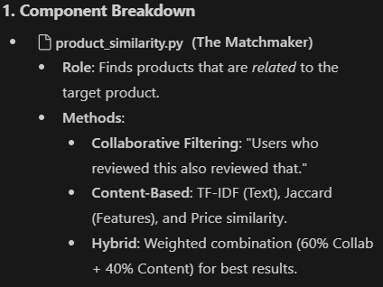
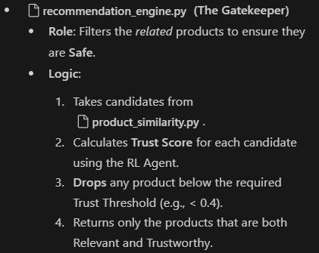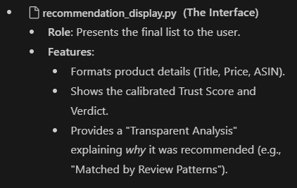

graph TD
A[Start Pipeline] --> B[Load Data & Calculate Trust Scores]
B --> C[Train RL Agent (PPO)]
C --> D[Select Target Product]
D --> E{Find Similar Products}
E -->|Method 1| F[Collaborative Filtering]
E -->|Method 2| G[Content-Based Filtering]
F & G --> H[Hybrid Ranking]
H --> I[Filter Candidates by Trust Score]
I -->|Score > Threshold| J[Safe Recommendations]
I -->|Score < Threshold| K[Discard (Risky)]
J --> L[Display Results to User]

